**Mastering Change: A Roadmap to Success - Key Elements to Watch for in an Effective Change Management Plan**

Embarking on a change initiative can be a complex and challenging process for any company.

There are several important factors to consider when increasing the likelihood of success. Here are some key things that a company should look out for:

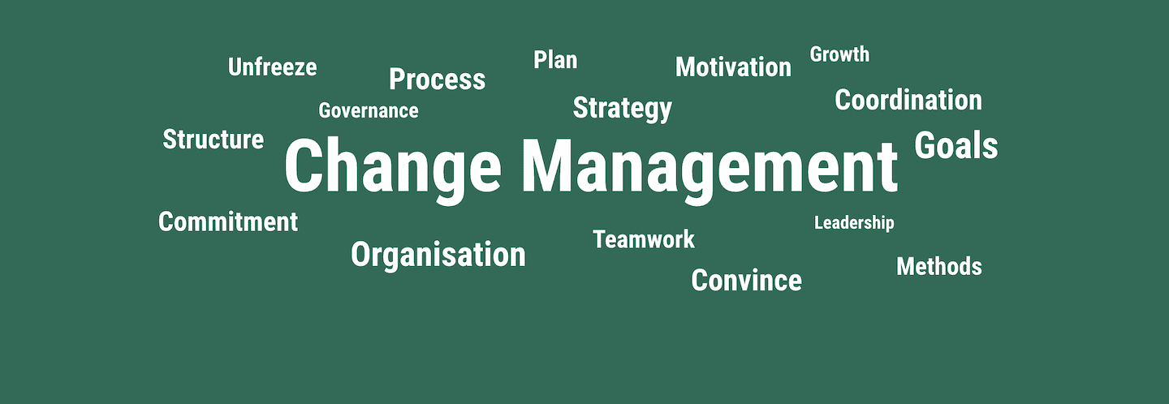

Change Management – Models, Processes & Software | OTRSmag

1. **Clear Vision and Goals**: Clearly define the purpose of the change initiative, what you aim to achieve, and how it aligns with the company's overall strategy. Having a well-defined vision and specific goals will help guide the entire initiative.
2. **Strong Leadership and Sponsorship**: Effective leadership is crucial for guiding change. Leaders should champion the initiative, communicate its importance, and actively support and engage with employees throughout the process.
3. **Stakeholder Engagement and Communication**: Identify and involve key stakeholders who will be impacted by the change. Effective communication is essential to address concerns, build understanding, and gain buy-in from all levels of the organization.
4. **Change Readiness Assessment**: Evaluate the organization's readiness for change. Assess the current culture, capabilities, and resources to determine if the company is equipped to handle the proposed changes.
5. **Resource Allocation**: Allocate the necessary resources, both in terms of finances and personnel, to support the change initiative. Insufficient resources can lead to delays, frustration, and ultimately, failure of the initiative.
6. **Change Management Plan**: Develop a comprehensive change management plan that outlines the steps, timeline, responsibilities, and milestones of the initiative. This plan should include strategies for addressing resistance and managing risks.
7. **Training and Skill Development**: If the change requires new skills or knowledge, ensure that adequate training and development programs are in place to equip employees with the capabilities needed to succeed in the new environment.
8. **Monitoring and Feedback Mechanisms**: Establish mechanisms to monitor progress and gather feedback from employees. This can help identify challenges early on and make necessary adjustments to the initiative.
9. **Mitigating Resistance**: Expect resistance to change, and have strategies in place to address it. Engage in open dialogue, address concerns, and involve employees in decision-making whenever possible.
10. **Celebrate Small Wins**: Acknowledge and celebrate the small successes achieved throughout the change initiative. This helps maintain morale and motivation, especially during longer projects.
11. **Flexibility and Adaptability**: Be prepared to adapt the change initiative based on feedback and changing circumstances. A rigid approach can hinder progress if unexpected challenges arise.
12. **Continuous Learning and Improvement**: Treat the change initiative as a learning opportunity. Regularly assess what's working and what's not, and make improvements accordingly.
13. **Sustainability and Integration**: Ensure that the changes become a part of the company's new normal. Integrate the changes into the culture, processes, and systems to prevent a relapse into old ways of doing things.
14. **Feedback Loop and Evaluation**: After the change has been implemented, establish a feedback loop to gather insights on the impact of the change. Regularly evaluate whether the intended outcomes have been achieved.

**About Me**

Montwedi ‘Monty’ Bakwena is a change management and digital transformation professional focusing on customer experience strategy, digital operations integration, channel migration, and public-private partnerships.

[Montwedibakwena@changemasters.co.bw](mailto:Montwedibakwena@changemasters.co.bw)

info@changemasters.co.bw

+26774987072